
Semester 1 Examination 2010

Question/Answer Booklet

MATHEMATICS 3C/D

Section Two

(Calculator Assumed)
Your name

Time allowed for this section
Reading time before commencing work: 10 minutes
Working time for paper: 90 minutes

Material required/recommended for this section

To be provided by the supervisor
Question/answer booklet for Section Two.
Formula sheet.

To be provided by the candidate
Standard items: pens, pencils, pencil sharpener, highlighter, eraser, ruler.
Special items: drawing instruments, templates, notes on up to two unfolded sheets of A4 paper, and up to three calculators, CAS, graphic or scientific, which satisfy the conditions set by the Curriculum Council for this course.

Important note to candidates
No other items may be taken into the examination room. It is your responsibility to ensure that you do not have any unauthorised notes or other items of a non-personal nature in the examination room. If you have any unauthorised material with you, hand it to the supervisor before reading any further.

Structure of this examination

 | Number of questions | Working time (minutes) | Marks available
Section One  Calculator Free | 7 | 45 | 36
This Section (Section 2)  Calculator Assumed | 10 | 90 | 72
Total marks |  |  | 108

Instructions to candidates

- The rules for the conduct of WACE external examinations are detailed in the booklet WACE Examinations Handbook. Sitting this examination implies that you agree to abide by these rules.

- Answer the questions in the spaces provided.

- Spare answer pages are provided at the end of this booklet. If you need to use them, indicate in the original answer space where the answer is continued i.e. give the page number.

- Show all working clearly. Any question, or part question, worth more than 2 marks requires valid working or justification to receive full marks. If you repeat an answer to any question, ensure that you cancel the answer you do not wish to have marked.

Section Two: Calculator-assumed (72 Marks)
This section has ten (10) questions. Answer all questions. Write your answers in the space provided.
Spare pages are included at the end of this booklet. They can be used for planning your responses and/or as additional space if required to continue an answer.
  - Planning: If you use the spare pages for planning, indicate this clearly at the top of the page.
  - Continuing an answer: If you need to use the space to continue an answer, indicate in the original answer space where the answer is continued, i.e. give the page number. Fill in the number of the question(s) that you are continuing to answer at the top of the page.

Suggested working time for this section is 90 minutes.

Question 8 (7 marks)
A particle moves in such a way that its acceleration at time t seconds is given by
a = 6t – 4 ms⁻². Given that initially the particle was at −3 metres and that it was at −8 metres one second later, find:
(a) the displacement as a function of time. (4 marks)

(b) when the particle is at rest 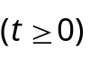 and its displacement at this time. (3 marks)

Question 9 (6 marks)
(a) The composite function f(g(x)) = e^{2x − 6}. Determine two different pairs of equations for functions f(x) and g(x). (2 marks)

(b) If f(x) = 3x² − 2 and h(x) = 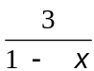 find h(f(x)). (2 marks)

(c) A composite function is defined by the equation h(f(x)) = 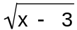 − 4. Determine the domain and range of this function for x real. (2 marks)

Question 10 (8 marks)
In the first five seconds of inflation, the relationship between the radius (r cm) and time (t sec) of a spherical party balloon are related by the formula
r = −t(t − 10)
(a) Show that the relationship between volume (V cm³) and time is given by V = 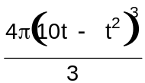
(1 mark)

(b) Determine the exact volume of the balloon 3 seconds after first being inflated. (1 mark)

(c) Determine the approximate change in volume as t increases from 3 to 3.01 sec. (4 marks)

(d) Determine the instantaneous rate of change of the volume with respect to the radius in the first five seconds. What common measurement can be found using this result?
(2 marks)

Question 11 (5 marks)
Consider the function f(x) = x³ + ax² + 2x + b where a and b are constants

(a) Find an expression for the gradient of the curve (1 mark)

(b) Given that the tangents at A(0, b) and B(2, 5) are parallel, find the value of a and b.
(4 marks)

Question 12 (8 marks)
(a) Comment on this ‘proof’.
Let 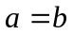
Then 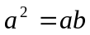 (multiplying both sides by a)
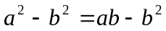 (subtracting 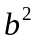 from both sides)
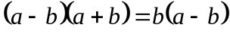 (factorising)
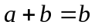 (dividing both sides by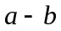)
2b = b (since a = b)
∴ 2 = 1 (dividing both sides by b)
(3 marks)

(b) Two points A and B are on a circle, and C is the other end of the diameter through A.
If AE is the perpendicular from A onto the tangent at B, prove that AB bisects angle CAE.
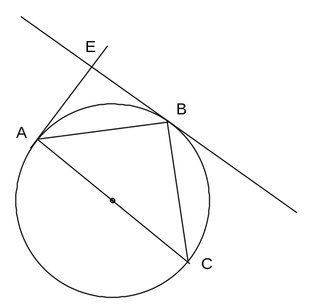

(5 marks)

Question 13 (8 marks)

The rectangle OABC drawn below has O at the origin, A lies on the positive x-axis, B lies on the curve y = e^{−ex} and C lies on the y-axis.

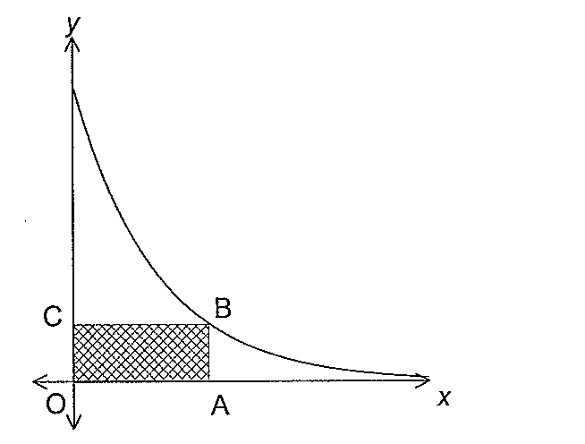
Use calculus techniques to find the greatest possible area of rectangle OABC.

Question 14 (7 marks)
On the axes below draw both of the curves 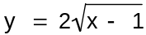 and y = x³ − x² − 5x − 4.
 (3 marks)
(a) Determine any points of inflection. (1 mark)

(b) Use calculus techniques to determine where the exact turning points occur. (3 marks)

Question 15 (8 marks)
A function is defined as y = pxe^{qx} where p and q are constants.
(a) Determine 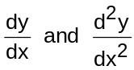. (3 marks)

(b) Using the results found in (a), determine the values for p and q so that y has a maximum of 1 when x = (5 marks)

Question 16 (9 marks)

Snow, on a tin roof, is melting at a rate proportional to the amount of snow left on the roof after
8 am. The rate of melting is 14 cm3/hour when there is 700 cm3 of snow left on the roof. At 8 am
there was 1000 cm3 of snow on the roof.
(a) Show that the amount of snow left on the roof at any time t after
8 am is given by 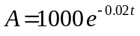 (3 marks)

(b) Determine at what time 10% of the snow will have melted. (3 marks)

At 3 pm, snow begins to fall and the amount of snow on the roof is given by
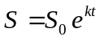 where t is the number of hours after 3 pm.
Given that there is 1000 cm3 of snow on the roof at 4 pm,
(c) determine the value of k. (3 marks)

Question 17 (6 marks)
Two competing cyclists are riding with constant speed. At 12 midday cyclist X is 40 metres north of a judge and is riding east at 9m/s, while cyclist Y is 70 metres east of the judge and is riding north at 7m/s.
(a) Show diagrammatically this situation (a scale diagram is not required) (1 mark)

(b) If the distance between the cyclists t seconds later is D metres, show that
D² = 6500 −1820t + 130t² (3 marks)

(c) Determine the time the cyclists are closest together and determine the minimum distance between them. (2 marks)

End Of Examination

